**One stop Marketing**

### 

**Project Code**

<Project code assigned by the Project Office>

**Project Manager**

Dr.Saad Razzaq

**Project Team**

Gul La Lae BSCS51F20R044 (Team lead)

Madiha BSCS51F20R048 (Team Member)

Hajra Anwar BSCS51F20R050(Team Member)

Umaima BSCS51F20R011(Team Member)

**Submission Date**

**1st July 2024**

**Table of Contents**

**Chapter 1: (Proposal)**

**1. Abstract 3**

**2. Background and Justification 3**

**3. Project Methodology 3**

**4. Project Scope 3**

**5. High level Project Plan 3**

**6. References 3**

**7. Gantt chart 3**

**Chapter 2: Software Requirements Specification**

**2. Introduction**

**2.1 Purpose of Document**

**2.2 Project Overview**

**2.3 Scope**

**Overall System Description**

**2.1 User Characteristics**

**2.2 Operating Environment**

**2.3 System Constraints**

4.1 User Class 1 – The Buyers

4.1.1 Functional Requirement 1.1

4.1.2 Functional Requirement 1.2

4.1.3 Functional Requirement 1.3

4.1.4 Functional Requirement 1.4

4.1.5 Functional Requirement 1.5

4.2 User Class 2 – Sellers

4.2.1 Functional Requirement 2.1

4.2.2 Functional Requirement 2.2

4.2.3 Functional Requirement 2.3

4.2.4 Functional Requirement 2.4

4.3 User Class 3 – Administrator

4.3.1 Functional Requirement 3.1

4.3.2 Functional Requirement 3.2

4.3.3 Functional Requirement 3.3

4.3.4 Functional Requirement 3.4

4.3.5 Functional Requirement 3.5

4.3.6 Functional Requirement 3.6

5. Non-functional Requirements

5.1 Usability

5.3 Performance

5.4 Maintainability

# Abstract

Our website will provide a platform where everyone can buy Like, Comments, Share and Views for their posts on different platforms like Facebook, Instagram, TikTok or any other platform. This website takes information from the customers through filling in their details. A customer registered on the website has the facility to buy packages which he requires. The proposed system is completely integrated with online systems. This automated system facilitates customers and provides them with the chance to fill in the details according to their requirements. Also providing a platform for people to register themselves as sellers and earn money. They will be assigned the task. Also, an AI functionality is added which is sentimental analysis in which the user just needs to paste link of their YouTube video to get videos analysis.

# Background and Justification

This time is era of World Wide Web where the world has become a global village, where the user needs to interact with the internet technology for survival and being competitive. The system will develop to be used for social media marketing platforms. It will be the online system where the user can view available Like, Share, Comments, View profile and Packages etc. Social media platforms contribute to business more significantly than traditional markets Competition between website, congestion of markets and traditional businesses led developers and management to consider alternative methods to build excitement in customers Many websites management systems are present that provide online shopping system. But the package system like share and comments for growing the shops, restaurants and apartments of the mall is not found mostly. As people become more accustomed to using the internet, they view the online system as a time saving and cost-saving system. Stockholders at distant locations are still able to deal with package management through this online system. The customers and other vendors are encouraged by the smooth buying and selling system.

# Project Methodology

The incremental model is not a separate model. It is necessarily a series of waterfall cycles. The requirements are divided into groups at the start of the project. For each group, the SDLC model is followed to develop software. The SDLC process is repeated, with each release adding more functionality until all requirements are met:

1. The Requirement and Definition
2. System and Software Design
3. Implementation and testing
4. System testing
5. Operation and maintenance.

Each of these phases is repeated if an error is discovered, this enables the correction of errors before moving to the next phase. A change management flow will be applied for the development of the system. An agile approach will be used.

We will develop this project by using following languages and tools:

* Php
* MySQL
* Python

The front-end to make this website attractive and efficient for the user consists of:

* HTML
* CSS
* JavaScript
* Bootstrap

In the next step, members will document the requirements and start working on design and other modules. Regular meetings will be held with the project supervisor to get further guidance and check-in of the current system. A user-friendly interface will be developed, and the system will be managed expertly.

# Project Scope

It is an online system for the social media marketing platform. We will make social media platforms to determine the module of our project which is used to fulfill our requirement for ensuring our project is justifiable.

Our website will be divided into different categories; each category will consist of different types of data. For example, the like package only has likes, and subscribe category will have to subscribe package. Our website works like a service because customers buy likes, share, comments so we will Payment _methods on the website. This project is a kind of marketing tool that helps everyone to boost their sales on different platforms like Facebook, Instagram, YouTube, etc. This project will also help people to earn by giving minimum time in a day. In this modern era of the world, everyone needs to grow their business on social media platforms because everyone is engaged in social media every time so for marketing purposes social media is a very good platform that is the reason we are targeting these platforms in this project and provide likes, comments share and views on customers posts and in return customer will pay to the site for services. This project will go to help a lot of people around the world to boost their sales through digital marketing, and by getting sentimental analysis on their YouTube video to know how viewers feel about the content they are posting that can help in planning next videos.

# High level Project Plan

The project plan has been illustrated in graphical which called as Gantt chart that involves the duration of tasks that shows what is the start and end time for activities in each stage of SDLC.

# Gantt Chart

|  |  |  |  |  |
| --- | --- | --- | --- | --- |
| Sr# | Task | Start Date | End Date | Duration |
| 1 | Creating a plan | 15-aug-23 | 30-aug-23 | 15 days |
| 2 | Documentation | 5-sept-23 | 5-nov-23 | 90 days |
| 3 | Developing a database | 5-nov-23 | 5-dec-23 | 30 days |
| 4 | Creating web structure | 5-dec-23 | 20-dec-23 | 15 days |
| 5 | Designing | 20-dec-23 | 15-jan-24 | 25days |
| 6 | Functionality | 15-jan-24 | 30-feb-24 | 45 days |
| 7 | Assigning Database to website | 30-feb-24 | 15-march-24 | 15 days |
| 8 | Testing of website | 15-march-24 | 30-march-24 | 15 days |
| 9 | Implementation | 30-march-24 | 12-april-24 | 12days |
| 10 | Final Testing | 12-april-24 | 10-may-24 | 23 days |

# Chapter 2: Software Requirements Specification

# 2. Introduction

# 2.1 Purpose of Document

The purpose of this document is to give a detailed description of the requirements for the "One Stop Marketing" website. It will illustrate the purpose and complete declaration for the development of system. It will also explain system constraints, interface, user characteristics, functional requirement and non-functional requirements for the project.

# 2.2 Project Overview

"One Stop Marketing" is creating a website where people can buy likes, comments, shares, and views for their social media posts. This helps businesses and individuals boost their online presence without the hassle of managing it themselves. Also, can register on the website and start earning by signing up as a seller and doing the task of like, comment and subscribe. Use AI for sentimental analysis on their YouTube video by pasting their video link.

# 2.3 Scope

We are creating an online system for social media marketing. People can buy likes, shares, comments, and more for their posts on platforms like Facebook and Instagram YouTube, TikTok. We'll have different categories for these services. This helps businesses and individuals grow their online presence and make money with minimal effort. This project will help a lot of people around the world to boost their sales through digital marketing. Giving people an easy earning platform as well.

# Overall System Description

This section will give an overall system description which includes user characteristics, operating environment and as well as system constraints. In user characteristics we will define our users and describe how the user can interact with system directly or indirectly.

After this we will discuss the operating environment of our system, in the operating environment we will describe the operating system in which our software runs successfully. At the end we will describe system constraint.

# 2.1 User Characteristics

It does require its users to have any specific computer knowledge. The user interface is in English language so users should have basic English reading knowledge.

There are three types of users that interact with the system:

1. Users of the Web App (services buyers)

2. Users of the Web App (services sellers)

3. Administrators

Each of these two types of users have a different use of the system so each of them has their own requirements. Buyers will find their relative packages on the site for using this web app service and the sellers are those people that are the actual employees of the system. Administrators manage overall the system so there is no incorrect information within it.

Administrators can delete and add any type of data into the site, firstly verified by admins and then will be shown on the website.

# 2.2 Operating Environment

This section gives the complete description about developer environment and user environment in which we see about developer and user system specification for use this website.

## 

## 2.2.1 Developer Environment

Our website will be developed in Windows operating system.

Developers have Toshiba laptops with 8 GB RAM and 250 GB ROM, Hp Pavilion 8 GB RAM 64-bit operating system, x64-based processor RAM 64-bit operating system, x64-based processor. For developing this website, we will use Xampp and visual studio code.

## 2.2.2 User Environment

For open website user must have any Browser like Google Chrome, Opera Mini etc. User must have internet connection.

# 2.3 System Constraints

## 2.3.1 Software Constraints

For using this website, users must have a web browser and internet connection. User search website URL in Web Brow for getting access to the website. Any type of laptop or mobile is used for getting access to the website.

## 2.3.2 Cultural Constraints

All the content on the website is shown only in the English language. Users must know the English language at least the beginner level.

# Chapter 3: Functional Specification

## 1. Introduction

## 1.1 Purpose of Document

The purpose of this document is to give a detailed description of the requirements for the software. It will illustrate the purpose and complete declaration for the development of system. It will also explain system constraints, interface, user characteristics, functional requirement and non-functional requirements for the project.

## 1.2 Project Overview

This project is a kind of marketing tool that helps everyone to boost their sales on different platforms like Facebook, Instagram, YouTube, etc. This project will also help people to earn by giving minimum time in a day. Sentiment analysis on YouTube videos helps creators understand audience reactions, improve content strategies, and manage brand reputation. It enables better engagement, trend identification, and personalized viewer experiences. Additionally, it supports market research and enhances monetization opportunities.

## 1.3 System Architecture

Our system consists of 3 tire architecture because we used Php, which consists of MVT (Model view controller) architecture.

## 3.4 Use cases

## 

|  |  |  |  |
| --- | --- | --- | --- |
| **<Use case 1: User Login>** | | | |
| **Actors:** 1) Buyers 2) Sellers | | | |
| **Use case Id:** | | 1 | |
| **Pre-condition:** | | User must be connected with the internet and user registration is required for login | |
| **Scenarios** | | | |
| **Step#** | **Action** | | **Software Reaction** |
| **1.** | User will enter his Email | | The System will check Email in the system |
| **2.** | User will enter his password | | The system will check user password that was stored in the authentication system |
| **3.** | User will click on login button | | The system will redirect the user to the home page of the website |
| **1a:** If user will enter wrong username or password the system will give the error and will ask to user re-enter his email or password.  **2a:** If the user will give wrong password 10 times the user account will be blocked. | | | |
| **Post Conditions** | | | |
| **Step** | **Description** | | |
| **1** | If the user will give right password and username then he will redirect to the home page of the website and perform any functionality. | | |

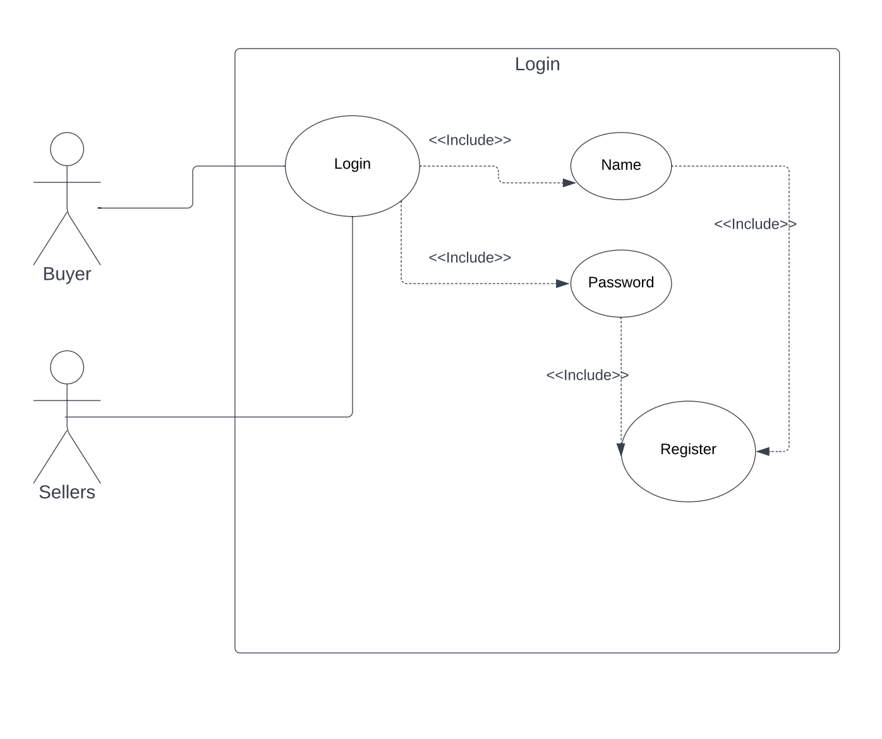

|  |  |  |  |
| --- | --- | --- | --- |
| **<Use case 2: User Registration >** | | | |
| **Actors:** 1) Buyers 2) Sellers | | | |
| **Use case Id:** | | 2 | |
| **Pre-condition:** | | User must be connected with the internet and will give the website URL on any web browser | |
| **Scenarios** | | | |
| **Step#** | **Action** | | **Software Reaction** |
| **1.** | Normal user will enter his complete detail that will be required for registration. | | The System will store all the information in the Authentication system |
| **2.** | The user will enter his email. | | The system will verify his Email and sends the opt for verification |
| **3.** | The super user will be created using command line system command will be used for super user. | | The system will check the command and allow the user to become a super user for the website. |
| **4.** | The super user will verify by email | | The system sends the Email to Super user and verifies them |
| **Alternate Scenarios:** *Write additional, optional, branching or iterative steps. Refer to specific action number to ensure understandability.* | | | |
| **1a:** If the user password and re-password didn’t match, the system gives the error and asked the user to re-enter your password.  **2a**. If user will give wrong Email id the system gives the error for correct Email.  **3a.** If email-id is not verified by the user, the registration system will not create a user account. | | | |
| **Post Conditions** | | | |
| **Step** | **Description** | | |
| **1** | After the successful registration the user will login in system as authorized user.  The system will store all the information about the user in the authentication system for future processes. | | |

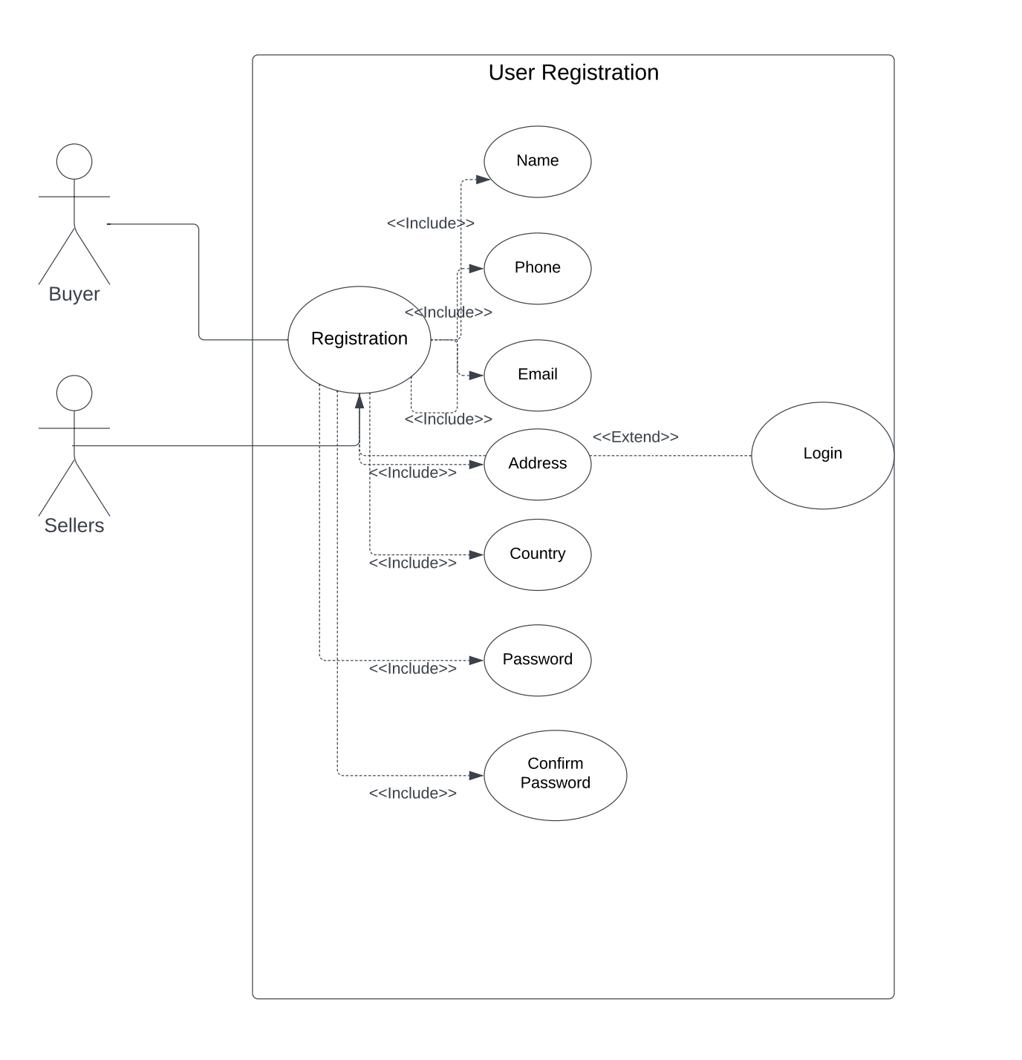

|  |  |  |  |
| --- | --- | --- | --- |
| **<Use case 3: Purchase Package >** | | | |
| **Actors:** 1) Buyers 2) Payment Method 3) Authentication | | | |
| **Use case Id:** | | 3 | |
| **Pre-condition:** | | User must be connected with the internet and will give the website URL on any web browser | |
| **Scenarios** | | | |
| **Step#** | **Action** | | **Software Reaction** |
| **1.** | Both users will view the packages on the website | | The System will show them all the packages |
| **2.** | Only register user will be purchase packages | | The Authentication system will check user registration information in the database |
| **3.** | The user will select package and checkout. | | The system will store packages on cart and show them on user profile |
| **Alternate Scenarios:** *Write additional, optional, branching or iterative steps. Refer to specific action number to ensure understandability.* | | | |
| **1a:** If users are not register on the website, they just view items and register themselves on website  **2a**. If any error occurs in the payment method, package order will be cancelled automatically. | | | |
| **Post Conditions** | | | |
| **Step** | **Description** | | |
| **1** | After the successful transaction the user will get package subscription or class papers and redirect to user profile page.  In the User profile page, he will check all the details about payment and his package. | | |

|  |  |  |  |
| --- | --- | --- | --- |
| **<Use case 4 Manage Packages >** | | | |
| **Actors:** 1) Admin | | | |
| **Use case Id:** | | 4 | |
| **Pre-condition:** | | User must be connected with the internet and will be able to manages all packages | |
| **Scenarios** | | | |
| **Step#** | **Action** | | **Software Reaction** |
| **1.** | The admin can manage the packages | | The System will show them all the detail of manage packages |
| **2.** | The admin can edit the package | | The Authentication system will edit the packages |
| **3.** | The admin can delete the packages | | The system will automatically delete the packages after finishing the bundle |
| **1a:** If admin is not register on the website, they just view items and register themselves to manage packages on website  **2a**. If any error occurs in the management package will cancel automatically. | | | |
| **Post Conditions** | | | |
| **Step** | **Description** | | |
| 4**1** | After successfully managing the packages, admin can edit or delete the packages.  In admin profile page he will check all detail about manage edit and delete his package. | | |

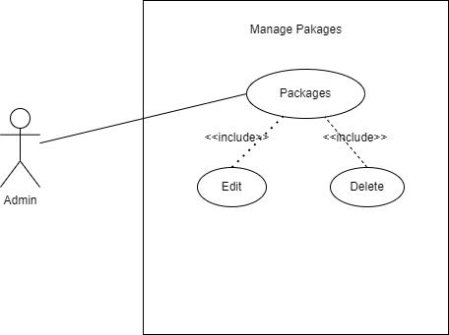

|  |  |  |  |
| --- | --- | --- | --- |
| **<Use case 5: Manage User >** | | | |
| **Actors:** 1) Admin 2) Authentication | | | |
| **Use case Id:** | | 5 | |
| **Pre-condition:** | | User must be connected with the internet and will give the website URL on any web browser | |
| **Scenarios** | | | |
| **Step#** | **Action** | | **Software Reaction** |
| **1.** | Admin will be able to manage all user | | The System will show them all the users |
| **2.** | The admin able to add delete edit their account | | The Authentication system will check user registration information in the database |
| **3.** | The admin can check out the user email. | | The system will verify the user email and show them on user profile |
| **Alternate Scenarios:** *Write additional, optional, branching or iterative steps. Refer to specific action number to ensure understandability.* | | | |
| **1a:** If users are not register on the website, they just view items and register themselves on website  **2a**. If any error occurs in user email will cancel automatically. | | | |
| **Post Conditions** | | | |
| **Step** | **Description** | | |
| **1** | . Admin will be able to manage all the users on the site. Able to add, edit or delete their accounts. The system will show all the information of the users to the admin i.e earnings, tasks, requests, services, etc. | | |

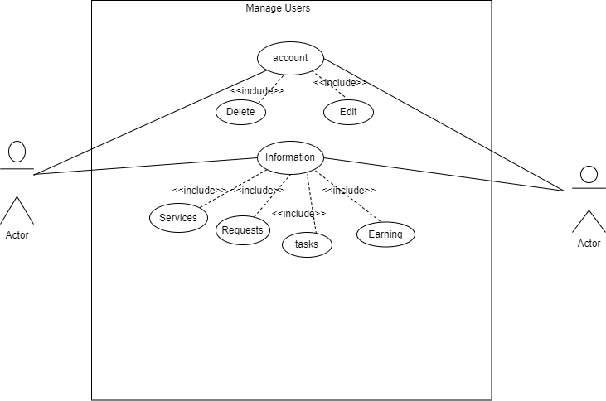

|  |  |  |  |
| --- | --- | --- | --- |
| **<Use case 6: Manage order >** | | | |
| **Actors:** 1) Admin | | | |
| **Use case Id:** | | 6 | |
| **Pre-condition:** | | User must be connected with the internet and will give the website URL on any web browser | |
| **Scenarios** | | | |
| **Step#** | **Action** | | **Software Reaction** |
| **1.** | Admin will be able to manage all order | | The System will show them all the orders |
| **2.** | The admin able to add delete edit their orders | | The Authentication system will check the orders details |
| **Alternate Scenarios:** *Write additional, optional, branching or iterative steps. Refer to specific action number to ensure understandability.* | | | |
| **Post Conditions** | | | |
| **Step** | **Description** | | |
| **1** | . Admin will be able to manage all the orders on the site. Able to add edit or delete their orders | | |

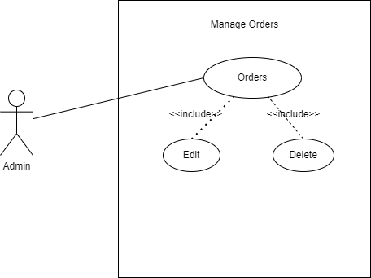

|  |  |  |  |
| --- | --- | --- | --- |
| **<Use case 7: Manage User Profile >** | | | |
| **Actors:** 1) Admin | | | |
| **Use case Id:** | | 7 | |
| **Pre-condition:** | | admin must be connected with the internet and will give the website URL on any web browser | |
| **Scenarios** | | | |
| **Step#** | **Action** | | **Software Reaction** |
| **1.** | Admin will be able to manage site slider | | The System will show them all the site slider |
| **2.** | The admin able to update delete and edit | | The Authentication system will check the sliders information |
|  |  | |  |
| **Alternate Scenarios:** *Write additional, optional, branching or iterative steps. Refer to specific action number to ensure understandability.* | | | |
| **Post Conditions** | | | |
| **Step** | **Description** | | |
| **1** | . Admin will be able to manage all the sliders on the site. Able to add edit or delete the sliders | | |

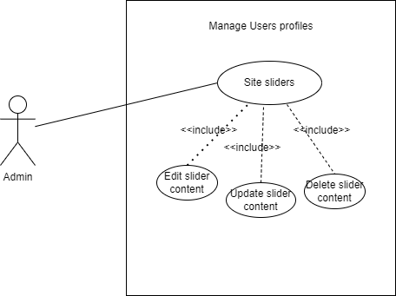

|  |  |  |  |
| --- | --- | --- | --- |
| **<Use case 8: Admin Profile>** | | | |
| **Actors:** 1) Admin | | | |
| **Use case Id:** | | 8 | |
| **Pre-condition:** | | admin must be connected with the internet and admin registration is required for login | |
| **Scenarios** | | | |
| **Step#** | **Action** | | **Software Reaction** |
| **1.** | admin will enter his Email | | The System will check Email in the system |
| **2.** | admin will enter his password | | The system will check user password that was stored in the authentication system |
| **3.** | admin will click on login button and update you email and password | | The system will redirect the admin to the profile page of the website and check the updates of profile |
| **Alternate Scenarios:** *Write additional, optional, branching or iterative steps. Refer to specific action number to ensure understandability.* | | | |
| **1a:** If the admin will enter wrong username or password the system will give the error and will ask the user to re-enter his email or password.  **2a:** If the admin will give wrong password 10 times the user account will be blocked. | | | |
| **Post Conditions** | | | |
| **Step** | **Description** | | |
| **1** | If the user will give right password and username then he will redirect to the home page of the website and perform any functionality. | | |

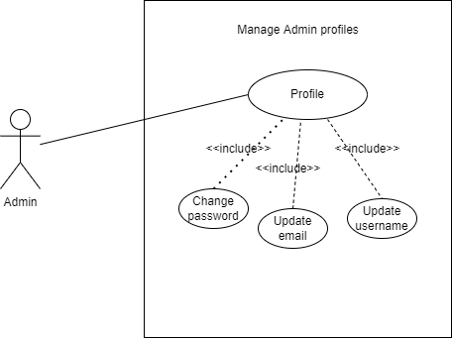

|  |  |  |  |
| --- | --- | --- | --- |
| **<Use case 9: Manage site preferences>** | | | |
| **Actors:** 1) Admin | | | |
| **Use case Id:** | | 9 | |
| **Pre-condition:** | | admin must be connected with the internet and admin registration is required for login | |
| **Scenarios** | | | |
| **Step#** | **Action** | | **Software Reaction** |
| **1.** | admin will manage all the site preferences | | The System will check the site preferences in the system |
| **2.** | admin will add edit delete preferences | | The system will check add delete preferences system |
| **3.** | admin will edit phone number and update you email and password | | The system will check all information on the site |
| **Alternate Scenarios:** *Write additional, optional, branching or iterative steps. Refer to specific action number to ensure understandability.* | | | |
| **1a:** If the admin will enter wrong username or password the system will give the error and will ask the user to re-enter his email or password.  **2a:** If the admin will give wrong password 10 times the user account will be blocked. | | | |
| **Post Conditions** | | | |
| **Step** | **Description** | | |
| **1** | Admin will be able to manage all the site preferences on the site. Able to add edit or delete preferences for example site email phone number address etc. | | |

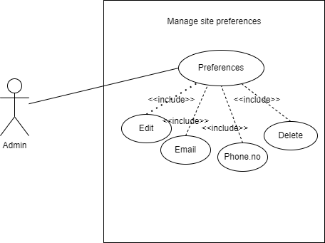

|  |  |  |  |
| --- | --- | --- | --- |
| **<Use case 10: Register >** | | | |
| **Actors:** 1) Admin 2) Sellers | | | |
| **Use case Id:** | | 10 | |
| **Pre-condition:** | | User must be connected with the internet and will give the website URL on any web browser | |
| **Scenarios** | | | |
| **Step#** | **Action** | | **Software Reaction** |
| **1.** | Normal user will enter his complete detail that will be required for registration. | | The System will store all the information in the Authentication system |
| **2.** | The user will give his email. | | The system will verify his Email and sends the opt for verification |
| **3.** | The seller create their account | | The system will approve the account |
| **Alternate Scenarios:** *Write additional, optional, branching or iterative steps. Refer to specific action number to ensure understandability.* | | | |
| **1a:** If the user password and re-password didn’t match, the system gives the error and asked the user to re-enter your password.  **2a**. If user will give wrong Email id the system gives the error for correct Email.  **3a.** If email-id is not verified by user, the registration system will not create user account and user cannot login. | | | |
| **Post Conditions** | | | |
| **Step** | **Description** | | |
| **1** | The seller creates their account as sellers and the admin will approve their account from the admin panel | | |

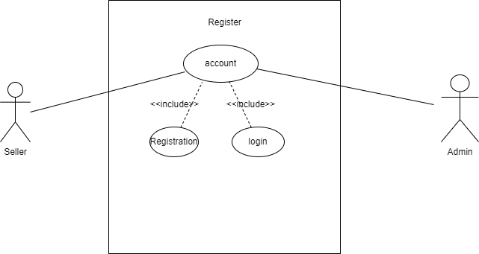

|  |  |  |  |
| --- | --- | --- | --- |
| **<Use case 11: Seller Services >** | | | |
| **Actors:** 1) Admin 2) Sellers | | | |
| **Use case Id:** | | 10 | |
| **Pre-condition:** | | User must be connected with the internet and will give the website URL on any web browser | |
| **Scenarios** | | | |
| **Step#** | **Action** | | **Software Reaction** |
| **1.** | Normal user will enter his complete detail that will be required for login. | | The System will store all the information in the Authentication system |
| **2.** | The user will send request for services. | | The system will show all detail of services |
| **Alternate Scenarios:** *Write additional, optional, branching or iterative steps. Refer to specific action number to ensure understandability.* | | | |
| **1a**.If email-id was not verified by user, the registration system user cannot login.  **2a**. if the user does not log for request services the system not show services | | | |
| **Post Conditions** | | | |
| **Step** | **Description** | | |
| **1** | After making account site will ask the seller what kind of services that user will providing so that the admin will send a request according to that request | | |

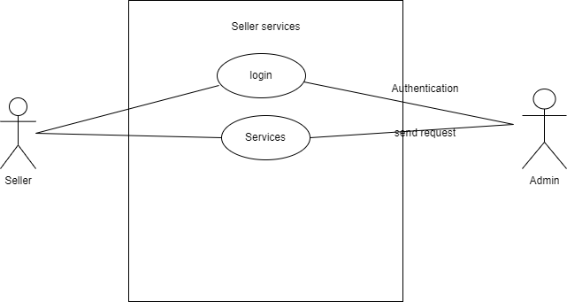

|  |  |  |  |
| --- | --- | --- | --- |
| **<Use case 12: Dashboard >** | | | |
| **Actors:** 1) Sellers | | | |
| **Use case Id:** | | 11 | |
| **Pre-condition:** | | User must be connected with the internet and will give the website URL on any web browser | |
| **Scenarios** | | | |
| **Step#** | **Action** | | **Software Reaction** |
| **1.** | Sellers will enter his complete detail work and earnings | | The System will store all the information of work and earnings in the Authentication system |
| **2.** | The sellers manage their task on the dashboard | | The System will store all the information of manages task in the Authentication system |
| **3.** | The sellers manage their reject task | | The system will store the information of reject task |
| **Alternate Scenarios:** *Write additional, optional, branching or iterative steps. Refer to specific action number to ensure understandability.* | | | |
| **1a.** If sellers are not registering the system will not provide the separate dashboard  **2a**. the seller cannot earn and manages their task | | | |
| **Post Conditions** | | | |
| **Step** | **Description** | | |
| **1** | The site will provide sellers with a separate dashboard so from that dashboard they are able to view their earnings and work details on the site and they can manage their tasks from the dashboard i.e. view, update, accept or reject tasks. | | |

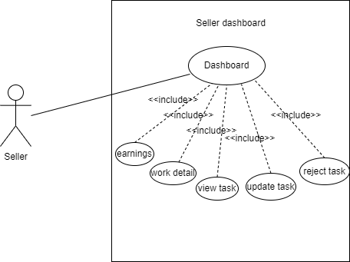

|  |  |  |  |
| --- | --- | --- | --- |
| **<Use case 13: Update Profile>** | | | |
| **Actors:** 1) Sellers | | | |
| **Use case Id:** | | 12 | |
| **Pre-condition:** | | User must be connected with the internet and user registration is required for login | |
| **Scenarios** | | | |
| **Step#** | **Action** | | **Software Reaction** |
| **1.** | User will enter his Name | | The System will check Name in the system |
| **2.** | User will enter his password | | The system will check user password that was stored in the authentication system |
| **3.** | User will click on login button and update his name password and profile | | The system will redirect the user to the home page of the website and check the update of the user profile name and password |
| **Alternate Scenarios:** *Write additional, optional, branching or iterative steps. Refer to specific action number to ensure understandability.* | | | |
| **1a:** If user enters wrong username or password system will give the error and will ask to user re-enter his email or password.  **2a:** If the user will give wrong password 10 times the user account will be blocked.  **3a:** If user will enter wrong username or password system will give the error and user cannot update the profile | | | |
| **Post Conditions** | | | |
| **Step** | **Description** | | |
| **1** | Sellers will be able to add their profile photo and other profile information, for example username password phone numbers etc. | | |

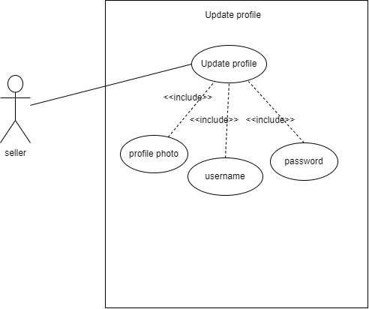

|  |  |  |  |
| --- | --- | --- | --- |
| **<Use case 14: View Package >** | | | |
| **Actors:** 1) User | | | |
| **Use case Id:** | | 13 | |
| **Pre-condition:** | | User must be connected with the internet and will give the website URL on any web browser | |
| **Scenarios** | | | |
| **Step#** | **Action** | | **Software Reaction** |
| **1.** | Both users will view the packages on the website | | The System will show them all the packages |
| **2.** | Only register user will be purchase packages | | The Authentication system will check user registration information in the database |
| **3.** | The user will select package and checkout. | | The system will store packages on cart and show them on user profile |
| **Alternate Scenarios:** *Write additional, optional, branching or iterative steps. Refer to specific action number to ensure understandability.* | | | |
| **1a:** If users are not register on the website, they just view items and register themselves on website  **2a**. If any error occurs in the payment method, package order will be cancelled automatically. | | | |
| **Post Conditions** | | | |
| **Step** | **Description** | | |
| **1** | The user will be able to view the package that is present on the site. There are different packages which the user will be able to buy any package from the site. | | |

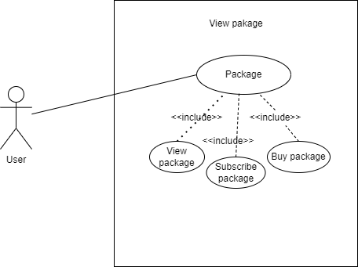

|  |  |  |  |  |
| --- | --- | --- | --- | --- |
| **<Use case 15: Request for services >** | | | | |
| **Actors:** 1) User | | | | |
| **Use case Id:** | | | 14 | |
| **Pre-condition:** | | | User must be connected with the internet and will give the website URL on any web browser | |
| **Scenarios** | | | | |
| **Step#** | **Action** | | | **Software Reaction** |
| **1.** | users send the request for services on the website | | | The System will show them all the services |
| **2.** | Only register user will be view services | | | The Authentication system will show user registration information for services |
|  |  | | |  |
| **Alternate Scenarios:** *Write additional, optional, branching or iterative steps. Refer to specific action number to ensure understandability.* | | | | |
| **1a:** If users are not register on the website, they just view items and register themselves on website for services  **2a**. If any error occurs the system will not send the send services and the system can cancel automatically. | | | | |
| **Post Conditions** | | | | |
| **Step** | | **Description** | | |
| **1** | | The user will be able to request the service in the system after login into his account. For example, a person wants to get likes on his post anywhere on social media, and he has a package already subscribed so he needs to submit a request that how many numbers of likes he wants and where he wants. | | |

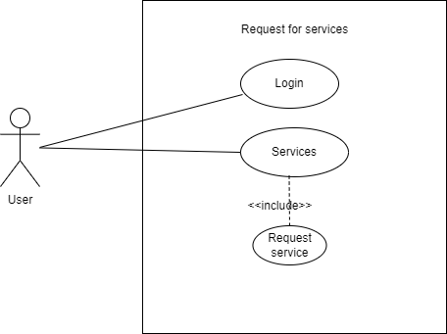

|  |  |  |  |  |
| --- | --- | --- | --- | --- |
| **<Use case 16: Check for Services Request Status >** | | | | |
| **Actors:** 1) Buyer | | | | |
| **Use case Id:** | | | 15 | |
| **Pre-condition:** | | | User must be connected with the internet and will give the website URL on any web browser | |
| **Scenarios** | | | | |
| **Step#** | **Action** | | | **Software Reaction** |
| **1.** | user's login on the website | | | The System will check the user login |
| **2.** | Only register user will be view status for services | | | The Authentication system will show user registration information for status services |
| **Alternate Scenarios:** *Write additional, optional, branching or iterative steps. Refer to specific action number to ensure understandability.* | | | | |
| **1a:** If users are not register on the website, they just view items and register themselves on website for services status  **2a**. If any error occurs the system will not send the send status services and the system can cancel automatically. | | | | |
| **Post Conditions** | | | | |
| **Step** | | **Description** | | |
| **1** | | Buyers have separate pages under their account where they can check the status for their request whether it is done or in pending status. | | |

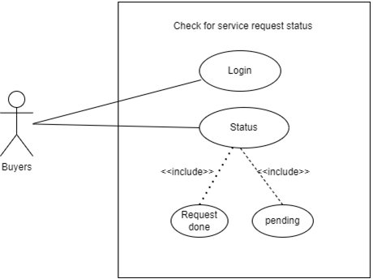

|  |  |  |  |
| --- | --- | --- | --- |
| **<Use case 17 Advance Sentiment Analysis >** | | | |
| **Actors:** 1) Buyers 2) Seller | | | |
| **Use case Id:** | | 2 | |
| **Pre-condition:** | | 1) User must be connected to the internet.  2)User registration is required for login. | |
| **Scenarios** | | | |
| **Step#** | **Action** | | **Software Reaction** |
| **1.** | The user clicks on the "Advanced Sentiment Analysis" feature within the website. | | The system activates the Advanced Sentiment Analysis tool. |
| **2.** | The user chooses a particular YouTube video for which they want to analyze comments and feedback. | | The system retrieves comments and feedback related to the selected post. |
| **3.** | The system utilizes VadereSentiment and emoji to analyze the sentiment of comments and feedback. | | Sentiment scores are generated, indicating the positive, negative, or neutral sentiment of the audience. |
| **4.** | The system displays the sentiment analysis results to the user. | | The user is presented with a visual representation or a summary of sentiment scores for better understanding. |
| **Alternate Scenarios:** *Write additional, optional, branching or iterative steps. Refer to specific action number to ensure understandability.* | | | |
| **1a:** If there are no comments or feedback for the selected video. The system informs the user that there is insufficient data for sentiment analysis.  **2a**. If there are technical issues during the sentiment analysis process. The system notifies the user of the issue and advises them to try again later. | | | |
| **Post Conditions** | | | |
| **Step** | **Description** | | |
| 4**1** | Upon successful completion of the sentiment analysis process, the user gains insights into the sentiment of their audience, enabling them to make informed adjustments to their content and engagement strategies. The results are available for the user's reference and decision-making in optimizing their social media presence. | | |

# Sequence Diagram:

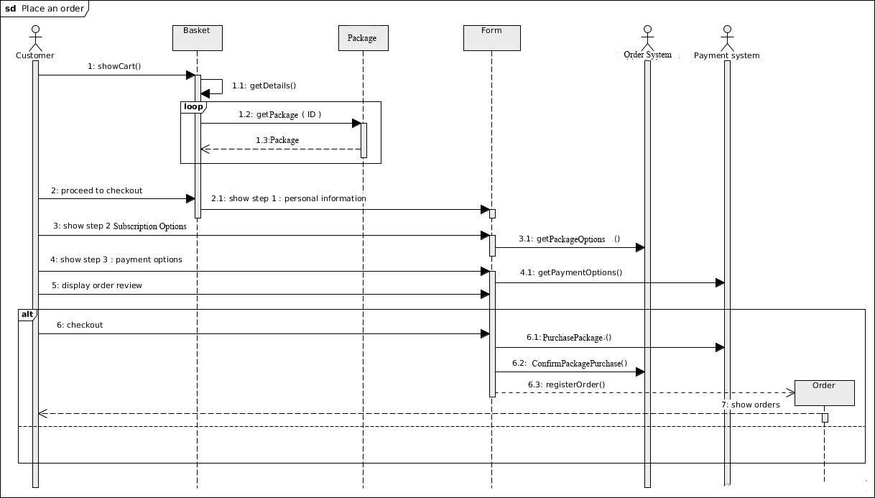

# Activity Diagram:

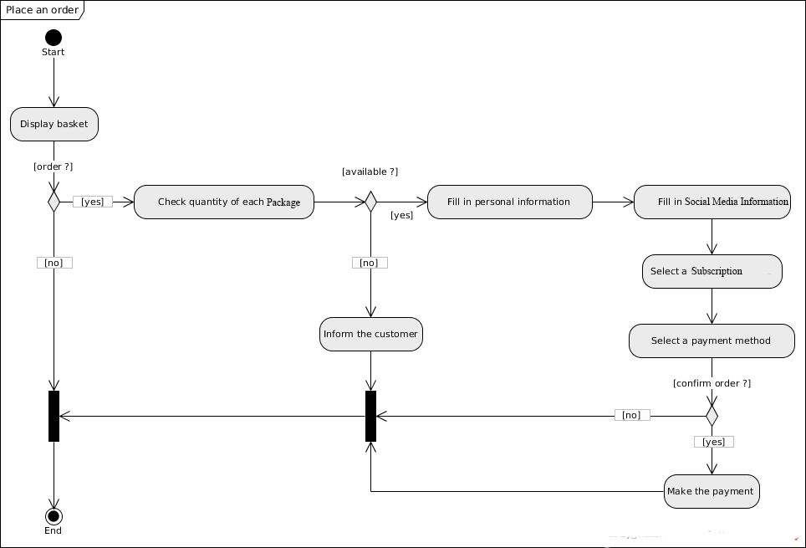

# Class Diagram:

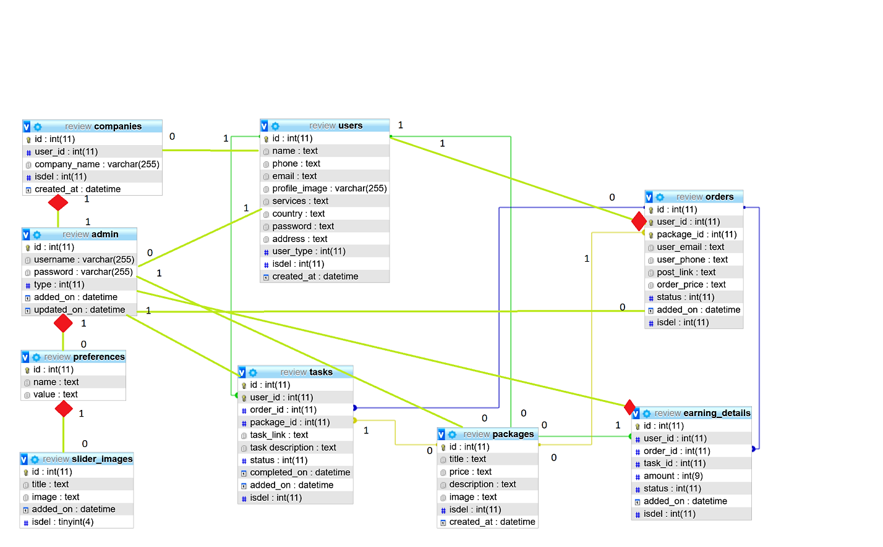

**ERD:**

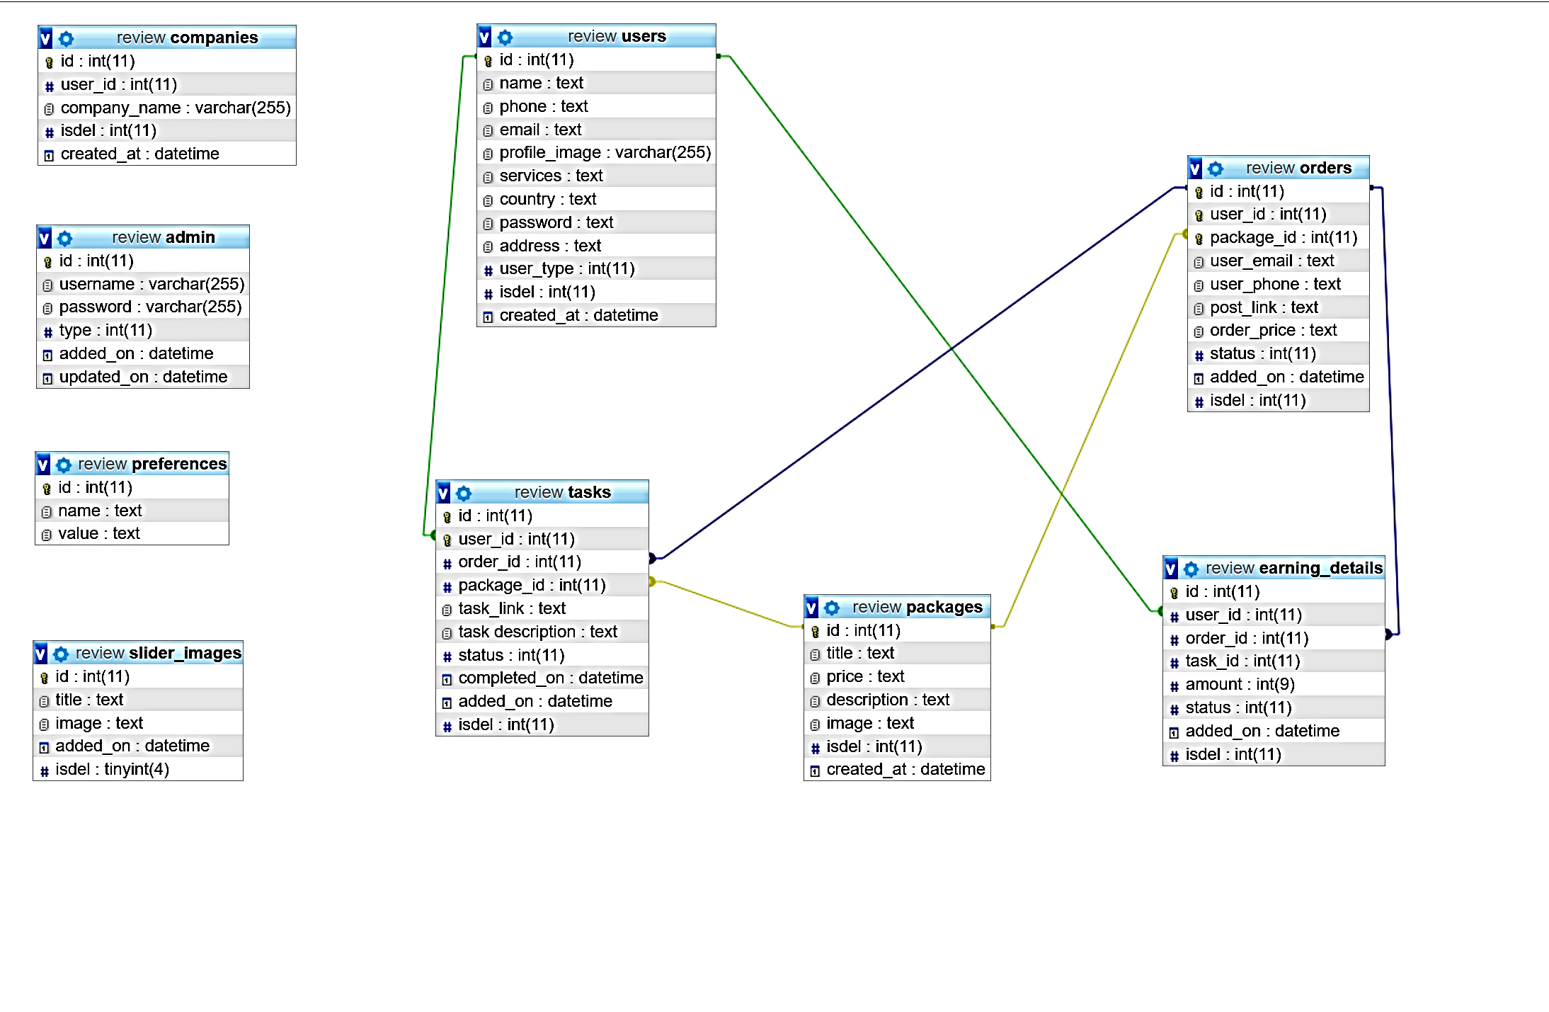

**Collaboration Diagram:**

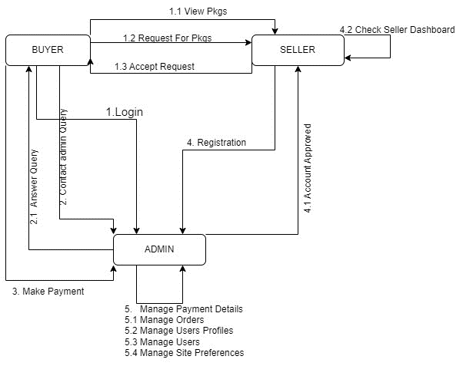

## 4 Functional Requirements

This section includes the requirements that specify all the fundamental actions of the software system. There are two types of users in the website so we define requirements for each user.

## 4.1 User Class 1 – The Buyers

## 4.1.1 View package

Description: The user will be able to view the packages that are present on the site. There are different packages which the user will be able to buy any package from the site.

## 4.1.2 Subscribe to Package

Description: The user will be able to view the packages that are present on the site. There are different packages which the user will be able to buy any package from the site.

## 4.1.3 Request for services

Description: The user will be able to request the service in the system after login into his account. For example, a person wants to get likes on his post anywhere on social media, and, he has a package already subscribed so he needs to submit a request that how many numbers of likes he wants and where he wants.

## 4.1.4 Check for service request status

Description: Buyers have separate pages under their account where they can check the

status for their request whether it is done or in pending status.

## 4.1.5 Contact Admin for Any Query

Description: Buyers can use live chat and contact admin directly to submit any query related to their services.

## 4.2 User Class 2 – Sellers

## 4.2.1 Register

Description: Sellers will be able to create their accounts as sellers and the admin will approve their account from the admin panel.

## 4.2.2 Seller Services

Description: After making an account site will ask the seller what kind of services the user will be providing us so the admin will send a request according to that request for example a user say only, he can provide likes on Facebook so the site will send work to him/her only about Facebook.

## 4.2.3 Seller Dashboard

Description: The site will be providing sellers a separate dashboard so from that dashboard they are able to view their earnings and work details on the site also they are able to manage their tasks from the dashboard i.e. view, update, accept or reject tasks.

## 4.2.4 Update Profile

Description: Sellers will be able to add their profile photo and also the other profile information for example username, password phone numbers etc.

## 4.3 User Class 3 – Administrator

## 4.3.1 Manage Users

Description: Admin will be able to manage all the users on the site. Able to add, edit or delete their accounts. The system will show all the information of the users to the admin i.e earnings, tasks, requests, services, etc.

## 4.3.2 Manage Packages

Description: Admin will be able to manage all the packages on the site. The admin is able

to add edit or delete packages.

**4.3.3 Manage Orders**

Description: Admin will be able to manage all the orders on the site. The user is able to add, edit or delete orders.

## 4.3.4 Manage Site Preferences

## Description: Admin will be able to manage all the site preferences on the site. The user can add edit or delete preferences, for example site email phone number address etc.

## 4.3.5 Manage Admin Profiles

## Description: Admin will be able to manage his profile i.e. change his password, update his email and username.

## 4.3.6 Manage Users Profile

## Description: Admin will be able to manage site sliders. Admin will be able to add edit delete and update the slider content of the website

# 5. Non-functional Requirements

In this section we will describe about non-functional requirements about our project in which include security, Availability, Maintainability, reliability, portability and documentation etc. Non-functional requirements are most important part in software development because we will describe it in detail.

## 5.1 Usability

No matter the size of your business, you want your website to be intuitive and easy to use. It takes about 0.05 seconds for users to figure out if your website is worth their time and attention. So, you’ll want to work on your homepage design, calls-to-action. Website usability is also defined by how easily a user can achieve their goal in a single page visit.

5.2 Performance

If your goal is increasing your website traffic, performance should be the priority NFR in your specification document. This NFR is often found in briefs from large enterprises or websites with legacy architecture: they want their e-stores to load fast no matter the number of integrations and sales seasons. Set up the speed benchmark, a maximum number of SKUs to be added, or any other performance indicator suitable to your business. Don’t include third-party system delivery time, though; your developers can’t do much if a certain business operation depends on an API call to another database.

example: The website’s homepage should load in less than 4 seconds on iOS 10+, Safari on 4G.

5.3 Maintainability

Maintainability is widely known that the tricky part of planning a business budget is accounting for the operational costs of business maintenance. Striving to make the website maintainable from the initial development phase means cutting the time and cost to identify and resolve the system faults in the future. As saddening as it may seem, there’s no escape from future issues and you can see many cues on how to maintain a website.

5.4 Scalability

If you are looking into a future-proof solution, scalability should be your take. This requirement defines how the website can grow and expand its functionality without affecting its performance. You should be able to add more memory, servers, or disc space to complete more transactions on your website. On the server-side, you might want to add localization features in case you plan to enter new markets and sell products internationally. Overall, this NFR accounts for painless business expansion and has both hardware and software implications.

## GitHub link for project repositories

https://github.com/Hajuhere/one-stop-marketing